The 3D Pac Man

In this project, I would like to make the game Pac Man into a first-person view 3D game. To do this, I intend to use the Tkinter module for drawing. While the mathematical model is based on 3D projection, as is shown in the following diagram:

[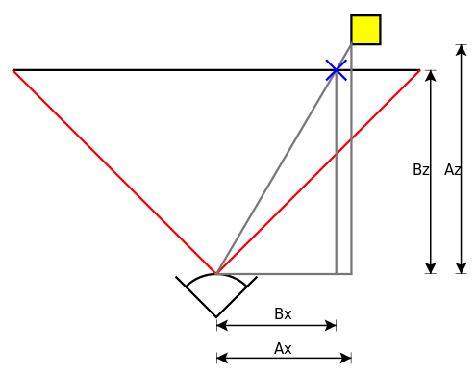](http://en.wikipedia.org/wiki/File:Perspective_transform_diagram.svg)

http://en.wikipedia.org/wiki/3D_projection

I have divided my project into 3 parts:

First, I will make a functioning 2D Pac man with most of the original AIs and rules.

Second, I will build a 3D projection system that converts 3D models to 2D graphs.

Third, I will build a mouse-based control system to replace the naïve keyboard-based control system (Key Strokes control the movements while mouse controls the view)

Using the 2D models from the first part, I can easily convert it to a 3D model since the height is fixed. Thus, I have the model of my game. Then I use the works from the second part to deal with the graphics part of my game. Finally, I upgrade my control to using mouse for view rotation.